Order Of Service

Singing: Psalm 19—CW page 70

Reading: Psalm 130

Opening Hymn: TLH 128

Reading: Romans 12:1-13

Request Hymn: CW Supplement 735

Reading: Matthew 22:1-14

Sermon Hymn: TLH 134

Sermon Text: Luke 4:1-13

In The Wilderness

Prayer

The Apostles’ Creed, TLH page 12

Holy Communion

The Lord's Prayer

The Blessing

Closing Hymn: TLH 129

* * * * * * * * * * *

Bible Study: Lambs: Prairie Dog
Sheep: Proverbs 27:21-24
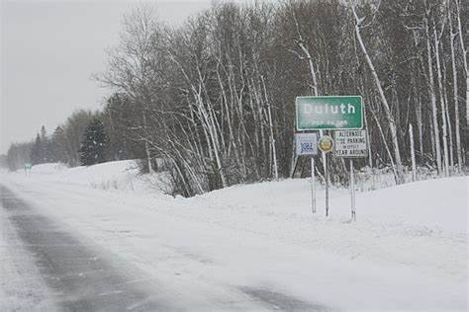

Welcome To Duluth, MN

Water
Of
Life

17 January 2021

W A T E R O F L I F E

Independent Christian Church—Conservative Lutheran Doctrine

Worship Service: 9:30 a.m. Bible Study: 10:45 a.m.

Larry Cooper, Pastor E-Mail address:
111 N. Ridge Road lcooper@wateroflife.cc
Coon Valley, WI 54623 Web Site:
www.wateroflife.cc

* * * * * * * * * * * * * * * * * * * * * * * * * * *

Sermon Text: Luke 4:1-13

In The Wilderness

* * * * * * * * * * * * * * * * * * * * * * * * * * *

1 And Jesus being full of the Holy Ghost returned from Jordan, and was led by the Spirit into the wilderness,
2 Being forty days tempted of the devil. And in those days he did eat nothing: and when they were ended, he afterward hungered.
3 And the devil said unto him, If thou be the Son of God, command this stone that it be made bread.
4 And Jesus answered him, saying, It is written, That man shall not live by bread alone, but by every word of God.
5 And the devil, taking him up into an high mountain, shewed unto him all the kingdoms of the world in a moment of time.
6 And the devil said unto him, All this power will I give thee, and the glory of them: for that is delivered unto me; and to whomsoever I will I give it.
7 If thou therefore wilt worship me, all shall be thine.
8 And Jesus answered and said unto him, Get thee behind me, Satan: for it is written, Thou shalt worship the Lord thy God, and him only shalt thou serve.
9 And he brought him to Jerusalem, and set him on a pinnacle of the temple, and said unto him, If thou be the Son of God, cast thyself down from hence:
10 For it is written, He shall give his angels charge over thee, to keep thee:
11 And in their hands they shall bear thee up, lest at any time thou dash thy foot against a stone.
12 And Jesus answering said unto him, It is said, Thou shalt not tempt the Lord thy God.
13 And when the devil had ended all the temptation, he departed from him for a season.

